**6.4.1 AREA: An Introduction**

In mathematics and geometry, **area** refers to the measure of the amount of space within the boundary of a two-dimensional object. It is usually expressed in square units, such as square meters or square feet. The concept of area is used to quantify the extent or size of a flat surface. It quantifies the amount of space enclosed by a shape.

Top of Form

Bottom of Form

For example, if you have a rectangle with a length of *L* units and a width of *W* units, the area (*A*) of the rectangle is given by the formula:

*A*=*L*×*W*

In the example shown, the area of the square is 12 square units because 12-unit squares are needed to cover the surface enclosed by the square.

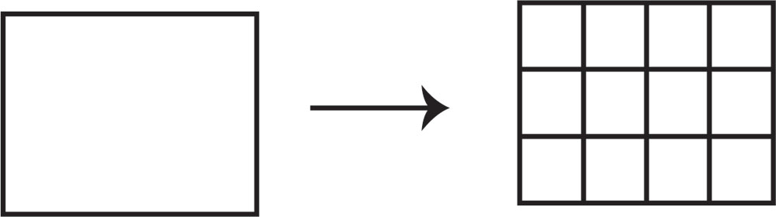

Figure 6.4.1 Area Units

The **perimeter** is defined as a measure of the length of the border that surrounds a closed geometric figure. The term perimeter derivates from the Greek words, ‘Peri’ and ‘meter’ which mean ‘around’ and ‘measure.’ In geometry, perimeter refers to the continuous line forming the path outside the two-dimensional shape. The area of a two-dimensional figure is defined as the amount of space inside the boundaries of the figure. It is a physical quantity that indicates the number of square units occupied by the two-dimensional object.

**6.4.2 Units for Measuring Area in Metric and US Standard**

Common units for measuring area include square meters, square feet, square kilometers, and acres, depending on the context and the scale of the area being measured. When working with area measurements, it's important to use the appropriate units based on the scale of the area being measured. For example, when designing a building, square footage is measured rather than square inches.

**US Standard System**

In the US standard system, area is typically measured in square feet (ft²) or square inches (in²). To calculate the area of a rectangular or square surface, you multiply the length of one side by the length of the other side.

For example, the area of a rectangle with a length of 10 feet and a width of 5 feet is calculated as follows: Area = Length × Width Area = 10 ft × 5 ft = 50 ft², the conversion between two square units is the square of the conversion between the corresponding length units.

1 foot = 12 inches, the relationship between square feet and square inches is:

1 square foot = 144 square inches, where = 12 in × 12in.

Similarly, 1 square yard = 9 square feet,

1 square mile = 3,097,600 square yards = 27,878,400 square feet

In addition, conversion factors include:

1 inch = 2.54 cm

=

1 square inch = 6.4516 square centimeters

1 square foot = 0.09290304 square meters

1 square yard = 0.83612736 square meters

1 square mile = 2.589988110336 square kilometers

The acre is also commonly used to measure land areas, where:

1 acre = 43,560 square feet = 4,840 square yards

An acre is approximately 40% of a hectare

**Metric System**

In the metric system, area is measured in square meters (m²) or square centimeters (cm²). The formula for calculating the area of a rectangular or square surface remains the same, but the measurements are in metric units.

For instance, if you have a rectangular surface with a length of 8 meters and a width of 3 meters: Area = Length × Width Area = 8 m × 3 m = 24 m²

Here are some common metric units for measuring area:

Square Millimeter (mm²): The square millimeter is an even smaller unit used for very small areas, often in microscopic or engineering applications.

Square Centimeter (cm²): The square centimeter is a smaller unit used for measuring smaller areas, especially in scientific contexts.

Square Meter (m²): The square meter is the base unit for area in the metric system. It is the area of a square with sides of one meter.

Square Kilometer (km²): The square kilometer is a larger unit of area often used for measuring large land areas, countries, or continents. One square kilometer is equal to 1,000,000 square meters.

Hectare (ha): The hectare is commonly used for measuring land areas, especially in agriculture and forestry. One hectare is equal to 10,000 square meters or 0.01 square kilometers.

These units are part of the International System of Units (SI) and provide a standardized way to express measurements of area in the metric system.

**6.4.3 Instruments Used to Measure Area**

Several instruments are used to measure area, depending on the context and the precision required. Here are some of them:

**Rulers or Tape Measures** are commonly used for measuring the lengths of sides of a shape, which can then be used to calculate the area of simple geometric shapes like rectangles and squares.

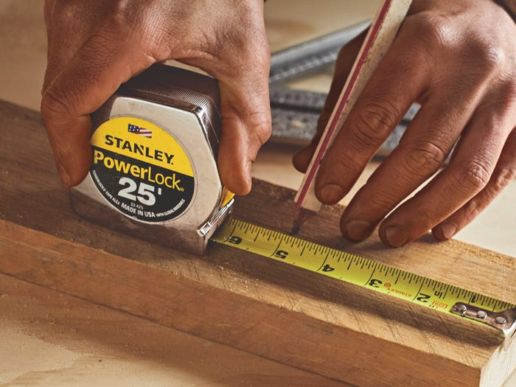

Figure: 6.4.2 Tape Measure

**Calipers** are used for measuring the dimensions of small objects with precision, often used in manufacturing and engineering.

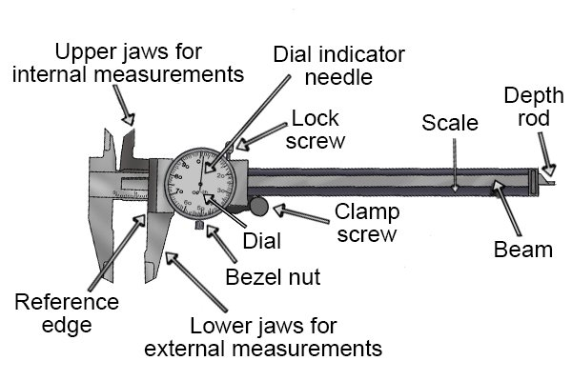

Figure: 6.4.3 Dial Caliper

**Planimeter** is a mechanical device used to measure the area of irregular shapes on a map or plan. It works by tracing the outline of the shape, and the device calculates the area based on the movement of its components.

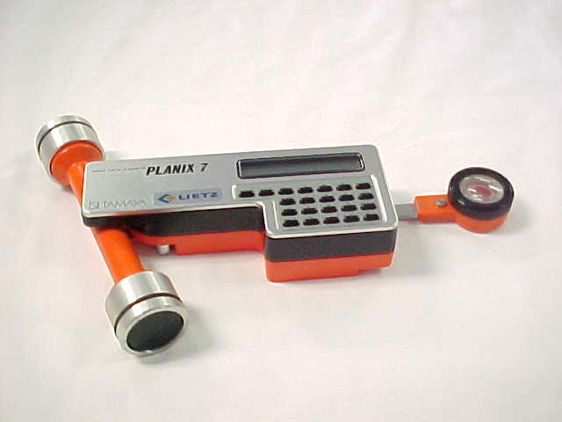

Figure: 6.4.4 Planimeter

**A Measuring Wheel**, also known as a surveyor's wheel, is a tool used to measure long distances on the ground. By rolling the wheel along a path, it records the number of rotations, which can then be used to calculate the area of a given area. Also known as a "measuring wheel" or "click wheel," surveyor's wheels are used to measure longer distances, such as those encountered in land surveying. They are often used for irregularly shaped areas.

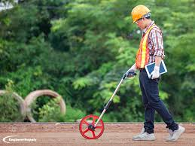 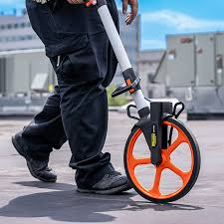

Figure: 6.4.5 Measuring Wheel

**GIS Software**, or Geographic Information Systems software, is used to analyze and measure areas of land, often for mapping purposes. These software applications can measure the area of polygons drawn on digital maps with high precision.

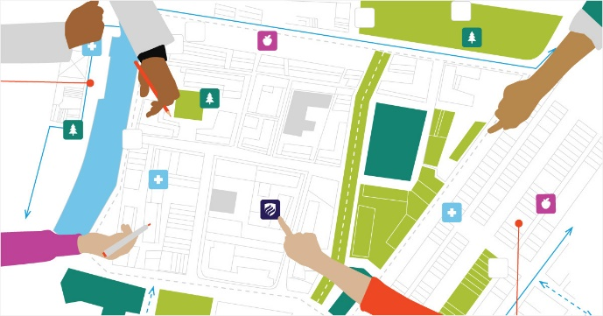

Figure: 6.4.5 Geographic Information System (GIS)

**Total Stations** are electronic devices used in surveying and construction to measure distances and angles. They can also be used to calculate the area of land parcels by taking multiple measurements and applying mathematical algorithms.

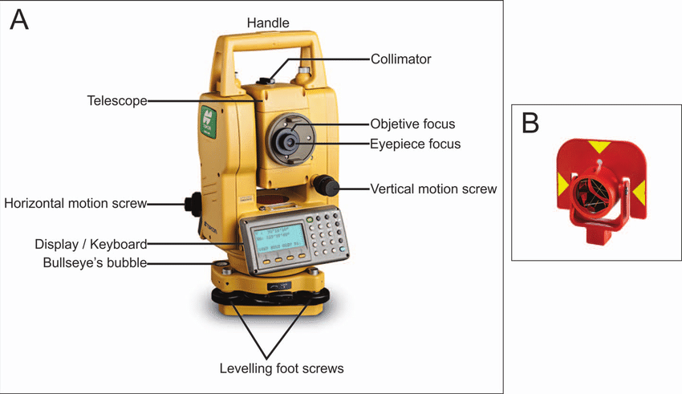

**Figure:** 6.4.6 Total Station

**Laser Distance Meters** use laser technology to measure distances accurately. By taking measurements of the lengths of the sides of a shape, the area can be calculated.

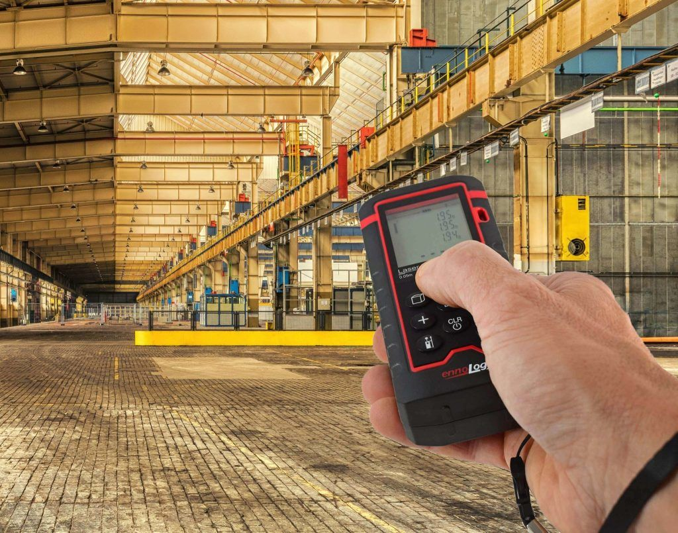

Figure: 6.4.7 Laser Distance Meter

**Satellite Imagery** or **Global Positioning System (GPS)** remote sensing technologies are used to measure large areas of land from space. Advanced algorithms process satellite data to calculate the area of land parcels, monitor changes over time, and conduct environmental assessments. It provides accurate location data that can be used to calculate area.

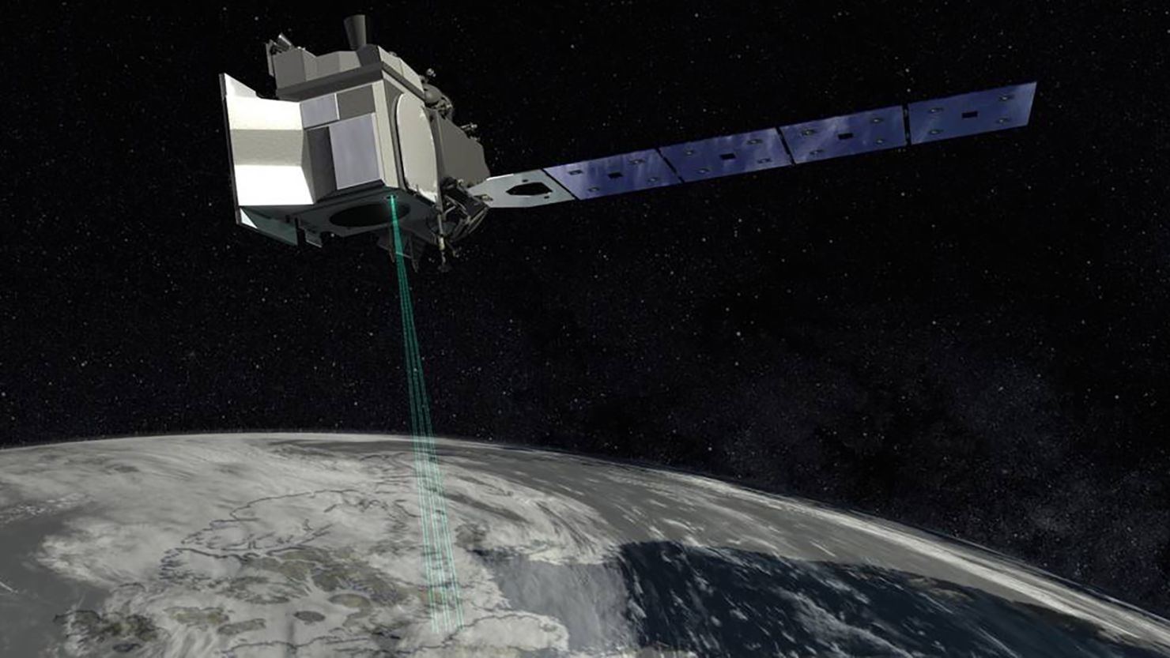

Figure: 6.4. 8 Satellite Imagery GPS

**Navigation Charts** are one of the most fundamental tools available to the mariner. A navigation chart is a map that depicts the configuration of the shoreline and seafloor. It provides water depths, locations of dangers to navigation, locations and characteristics of aids to navigation, anchorages, and other features.

A Navigation Chart Scale is an essential tool for mariners, indicating coastlines, depths, and navigational hazards. The scale of a navigation chart relates distance on the chart to distance in the real world. For example, a scale of 1:50,000 means that one unit of length on the chart (e.g., 1 inch) represents 50,000 units of the same length in the real world (e.g., 50,000 inches or approximately 0.8 nautical miles).

The navigation chart is essential for safe navigation. Mariners use charts to plan voyages and navigate ships safely and economically. Federal regulations require most commercial vessels to carry electronic or paper navigation charts while they transit U.S. waters.

Since the mid-1830s, the U.S. Coast Survey (a NOAA predecessor agency) has been the nation’s navigation chart maker. NOAA's Office of Coast Survey is still responsible for creating and maintaining all charts of U.S. coastal waters, the Great Lakes, and waters surrounding U.S. territories.

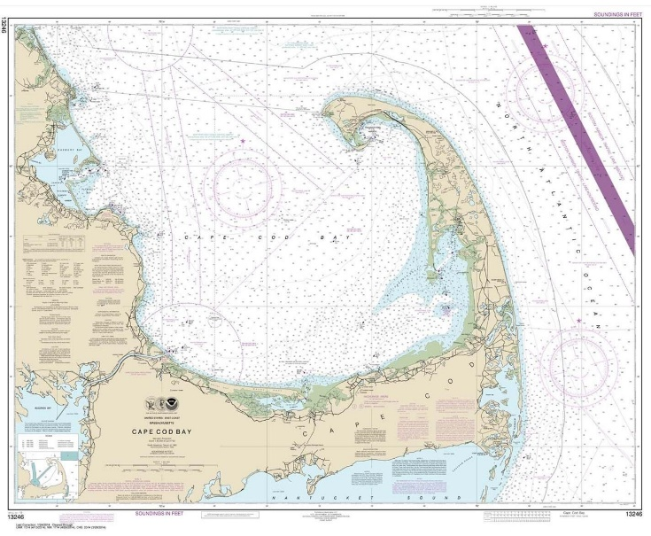

Figure: 6.4.9 Navigation Chart

**Bathymetric Charts** focus on the depths and contours of underwater surfaces. These charts provide valuable information for marine engineering projects and navigation, allowing engineers to assess the seabed's topography and plan accordingly.

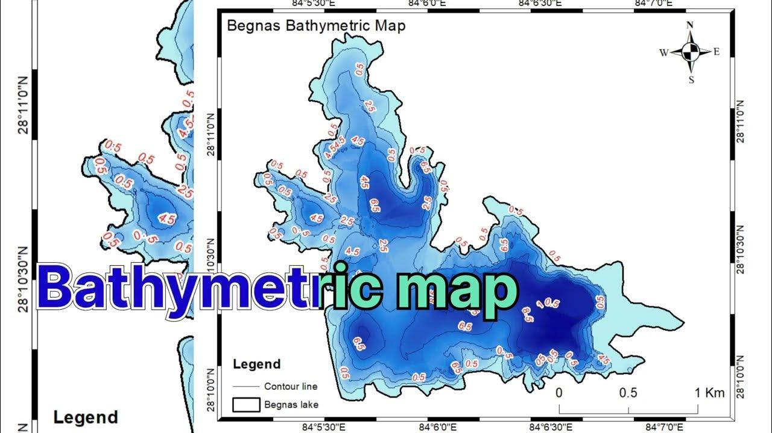

Figure: 6.4.10 Bathymetric Map

These are just a few examples of instruments and technologies used to measure area, each suited to different applications and levels of precision.

**6.4.4 Area in Math**

There are several well-known formulas for the areas of simple shapes such as triangles, rectangles, and circles. Using these formulas, the area of any polygon can be found by dividing the polygon into triangles.For shapes with a curved boundary, calculus is usually required to compute the area. Indeed, the problem of determining the area of plane figures was a major motivation for the historical development of calculus.

Mathematics provides various formulas and methods to find the area of different shapes and surfaces. Here are some common mathematical approaches:

**Geometric Formulas:** For basic shapes like rectangles, squares, triangles, circles, and polygons, there are well-known formulas to calculate their areas. For instance:

Area of a **square**:

To calculate the area of a **square**, multiply the length of one side by the other (equal length sides).

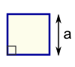

Area = a2

 a = length of side

Area of a **rectangle**:

To calculate the area of a **rectangle,** multiply the width by the height.

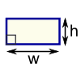

Area = w × h

w = width

h = height

Area of **Triangle**:

To calculate the area of a **triangle**, multiply the base times the height.

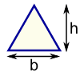

Area = ½ × b × h

b = base

h = vertical height

Area of **Circle:**

To calculate the area of a circle, multiply 3.14 (pi Ω) by the radius squared.

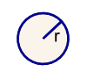

Area = **π** × r2

r = radius

**Integration**: For irregular shapes or curves, calculus can be used. By integrating appropriate functions over a given interval, you can find the area under a curve or between curves. This method is particularly useful for finding the area of regions bounded by curves in the Cartesian coordinate system.

**Dissection and Composition**: This method involves decomposing complex shapes into simpler shapes whose areas are known. For example, a complex shape might be divided into rectangles, triangles, circles, etc., and then the areas of these simpler shapes are calculated individually and summed up to find the total area.

**Coordinate Geometry**: In the Cartesian coordinate system, the area of a polygon can be calculated using the shoelace formula or by dividing the polygon into triangles and summing their areas.

**Vector Calculus**: In three-dimensional space, vector calculus can be used to find the area of surfaces. For example, the surface area of a parametrically defined surface can be found using a surface integral.

**Limit Process**: The area of a shape can also be approximated using a limit process, where you divide the shape into smaller and smaller pieces and sum their areas. As the size of the pieces approaches zero, the sum converges to the exact area of the shape.

These are just a few examples of how mathematics can be used to find area, and there are many other techniques and methods depending on the specific shape or surface being considered.

**6.5.1 VOLUME**

**Volume** is the amount of three-dimensional space an object or substance occupies. It is a scalar quantity, meaning it has magnitude but no direction. The concept of volume is used to quantify the extent of a region in space and is typically expressed in cubic units. Volume measures capacity.

**6.5.2 Units for Measuring Volume**

These are some of the most commonly used units for measuring volume, but there are others as well, depending on specific contexts and regions. Also, there may be *dry* or *wet* measures of volume.

**US Standard System:** In the US standard system, volume is typically measured in cubic feet (ft³) or cubic inches (in³).

The primary units for measuring volume include:

* + Cubic Inch (in³): The cubic inch is a small unit of volume commonly used in engineering and manufacturing contexts.
  + Cubic Foot (ft³): The cubic foot is a larger unit of volume often used in construction and real estate. One cubic foot is equivalent to the volume of a cube with sides of one foot. There are 1,728 cubic inches in one cubic foot.
  + Fluid Ounce (fl oz): The fluid ounce is commonly used for measuring liquid volumes, especially in the context of beverages and cooking.
  + Pint (pt): The pint is a unit of liquid volume. In the U.S., there are two types of pints: the liquid pint (equal to 16 fluid ounces) and the dry pint (used for measuring dry goods).
  + Quart (qt): The quart is a unit of liquid volume. Like the pint, there are two types: the liquid quart (equal to 32 fluid ounces) and the dry quart.
  + Gallon (gal): The gallon is a larger unit of liquid volume, equal to 128 fluid ounces. 1 US gallon is equivalent to 231 cubic inches.

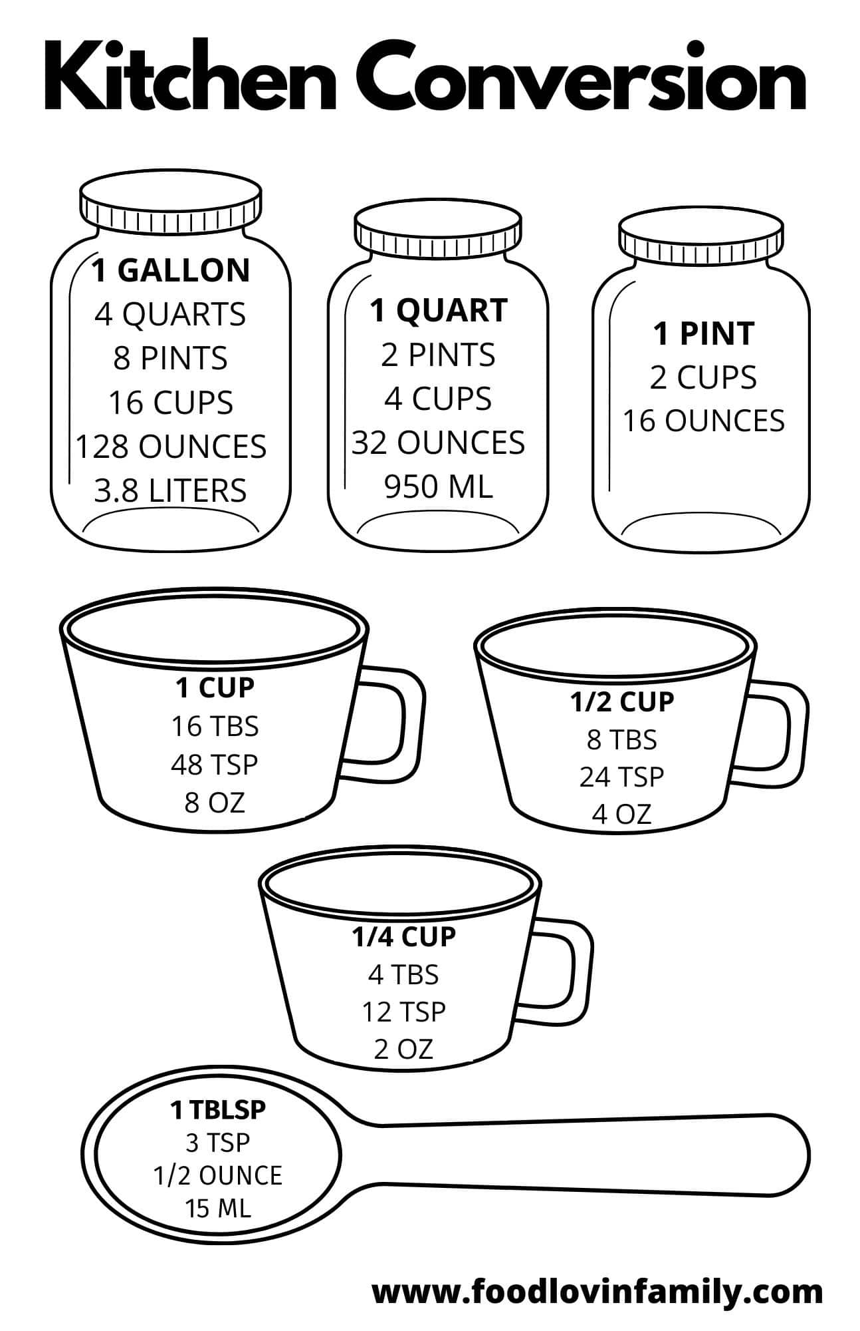

Figure: 6.5.1 Kitchen Conversions

**Barrel:** The amount of liquid a barrel contains can vary depending on the type of barrel and its size. The most common types of barrels used for liquids are oil barrels and whiskey barrels. The standard size for an oil barrel is 42 US gallons (approximately 159 liters). However, there are also other sizes used in different regions and industries. It’s important to note that the capacity of a barrel can vary depending on its construction and specific dimensions, but these are the standard sizes for these types of barrels.

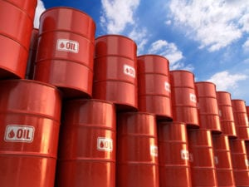

Figure: 6.5.2 Barrels

**Drum:** one common size is the 55-gallon drum, which is prevalent for industrial and commercial use. This size of drum can hold approximately 55 US gallons of liquid, which is roughly equivalent to 208 liters.

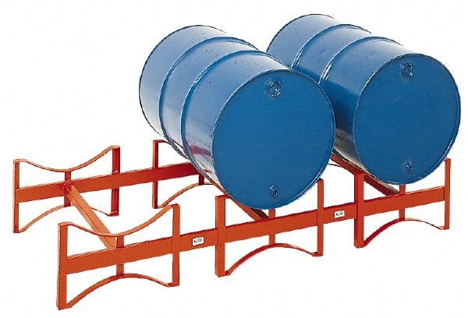

Figure: 6.5.3 Drums

**Metric System:** The standard unit for measuring volume in the International System of Units (SI) is the cubic meter (m³) or cubic centimeters (cm³).

Similar to the US standard system, the volume of regular-shaped objects is determined by multiplying the three dimensions in metric units. For example, if you have a rectangular prism with dimensions 2 meters by 4 meters by 1 meter: Volume = Length × Width × Height Volume = 2 m × 4 m × 1 m = 8 m³

In the metric system, volume is typically measured using the liter (L) as the standard unit. The liter is equivalent to 1 cubic decimeter (dm³). The cubic meter (m³) is the standard unit for larger volumes. Here are some common metric units for measuring volume:

* Cubic Meter (m³): The cubic meter is the SI unit for volume and is equal to the volume of a cube with sides of one meter.
* Liter (L): The liter is commonly used for everyday measurements of liquid volumes. One liter is equal to 1 cubic decimeter.
* Milliliter (mL): The milliliter is a smaller unit used for precise measurements of liquids. One milliliter is equal to one-thousandth of a liter.
* Cubic Centimeter (cm³): The cubic centimeter is often used in scientific and medical contexts for measuring the volume of small objects or substances. It is equivalent to one milliliter.

In summary, the liter is the most common unit for expressing volume in the metric system, especially in everyday situations. The cubic meter is used for larger volumes, and smaller units like milliliters and cubic centimeters are used for more precise measurements. The metric system provides a straightforward and decimal-based system for measuring volumes, making it widely adopted in scientific and everyday applications around the world.

**The Ton: A Ton** has a long history and has acquired several meanings and uses.

Depending on context, a ton may refer to a unit measure of mass, volume or force. For volume, it could be a dry or wet measure.

In transportation, one metric ton can be equal to one cubic meter (CBM) of volume. A CBM is a unit of measurement used in the shipping and transportation industries to show how much space a shipment takes up: 1 meter x 1 meter x 1 meter (or 1 cubic meter).

The amount of liquid that one ton contains depends on the density of the liquid. Density is a measure of how much mass is contained in a given volume.

[**Density**](https://www.engineeringtoolbox.com/density-specific-weight-gravity-d_290.html)is the ratio of the mass to the volume of a substance:

Density = = ρ = m / V

**Density of Water US System**

**Mass (m)** refers to the amount of water measured in pounds (lbs.).

**Volume (V)** refers to the volume of water measured in cubic feet (ft³).

One cubic foot of water weighs 62.4 lbs. @ 39.2°F

Density == 62.4 lbs. = = 62.4 lb./ft³

**Density (ρ, rho):** The density of w.ater in pounds per cubic foot (lbs./ft³) is 62.4 lbs./ft³

**Density of Water Metric System**

One cubic meter of water weighs 1000 kilograms (kg) @ 4°C

Volume equals one cubic meter

Density = = 1000 kg/

*English or Long Ton = 2240 lb. (1016.05 kg)*

*'American or Short Ton' = 2000 lb. (907.18 kg)*

*'Tonne or Metric Ton' = 1000 kg (2204.62 lb.)*

*'Measurement or Shipping Ton' = 1 cubic meter.*

So, the volume of liquid that one ton contains depends on the density of the specific liquid you're considering.

**6.5.3 Instruments for Measuring Volume**

When dealing with regular-shaped objects like cubes or rectangular prisms, you calculate the volume by multiplying the length, width, and height of the object. For instance, the volume of a cube with sides measuring 3 feet each is calculated as follows: Volume = Length × Width × Height Volume = 3 ft × 3 ft × 3 ft = 27 ft³.

Various instruments are used to measure volume, and the choice of instrument depends on the nature of the substance being measured (solid, liquid, or gas) and the required level of precision. Here are some common measuring instruments for determining volume:

**A Graduated Cylinder** is a cylindrical container marked with calibrated lines to indicate volume. It is commonly used in laboratories to measure the volume of liquids.

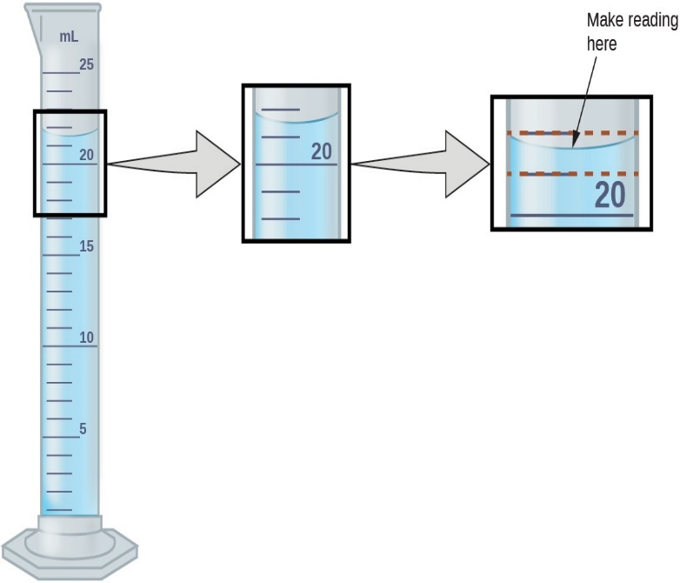

Figure: 6.5.4 Graduated Cylinder

**Beakers** are cylindrical or conical containers with volume markings. While they are not as precise as graduated cylinders, they are often used for approximate volume measurements.

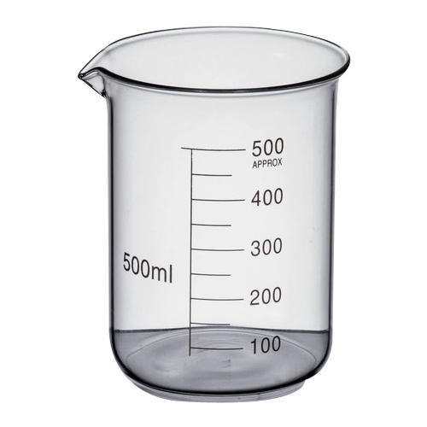

Figure: 6.5.5 Beaker

**Pipettes** are calibrated glass or plastic tubes used to measure and transfer small volumes of liquids with high precision. There are different types, including volumetric pipettes and micropipettes.

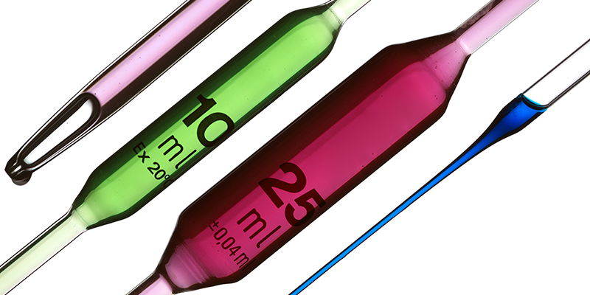

Figure: 6.5.6 Pipettes

**A burette** is a long, graduated tube with a valve at the bottom. It is commonly used in analytical chemistry for precise dispensing of liquids.

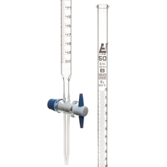

Figure: 6.5.7 Burette

**A gas syringe** is used to measure the volume of gases in chemical reactions. The plunger is pushed or pulled to change the volume, and the graduations on the syringe indicate the volume of the gas.

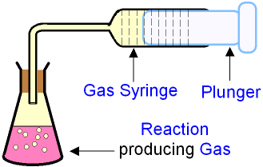

Figure: 6.5.8 Gas Syringe

**Geometric Instruments** (for Irregular Shapes): For irregularly shaped objects, displacement methods or geometric instruments like Archimedes' principle can be used to determine volume.

**Laser scanners** use laser technology to create a three-dimensional point cloud representation of an object's surface. By analyzing the point cloud, engineers can calculate the object's volume with high accuracy.

**6.5.4 Volume Measurements Aboard Ship**

In the nautical world, understanding volume measurements is crucial for various maritime activities and engineering projects. Two nautical-specific volume measurements are:

**Displacement Volume**: In naval architecture, displacement volume refers to the volume of water displaced by a floating vessel, such as a ship or boat. It is an essential measurement for determining a vessel's buoyancy and stability.

**Cargo Capacity**: For shipping and maritime logistics, measuring the cargo capacity of a vessel is vital. It involves calculating the available space inside the ship to transport goods, ensuring efficient and safe cargo handling.

Along with these are the measurements of various liquids held in tanks aboard ships. To determine this we use the term, *soundings.*

**SOUNDINGS**

## ****What is Sounding?****

Checking the level of the fluid in a tank is considered part of the sounding process on ship. The final sounding value of the tank is the total quantity of fluid (oil, bilge, sludge, or water) inside a ship’s tank. The initial process is to first measure the depth of the fluid from the surface to the bottom of the tank by using sounding tape.

The sounding tape value is later used in calculation of the final sounding value, which is derived using the sounding table, taking the list and trim of the ship into account and the temperature at which the fluid (specifically for oil) is stored (as density of oil is affected by temperature).

**Importance of Sounding**

Is it necessary to take soundings of various tanks every day? Yes.

In some cases, the sounding has to be taken in every watch. A ship is a floating factory with several mechanical systems working continuously. These systems require fuel oil, lube oil and water to operate, and these fluids are consumed from service tanks or sump tanks. The service and sump tanks on a ship need to be sounded every watch to ensure the level is maintained.

The service tanks and sump tanks levels are maintained by filling them up with appropriate fluid using storage tanks, which are sounded once in a day.

The four most important operations which are dependent on the sounding values are:

1. **Stability of the Ship:** The ship stability highly depends on how various fluids (oil, water, fluid cargo etc.) are stored to tackle the free surface effect, which is a very important factor for defining ship’s stability
2. **Voyage Planning:** The current volume of fluids (oil, water etc.) in various tanks and the estimated volume needed to reach the next port or complete a voyage needs to be known before the ship sails. This is to ensure a minimum quantity is always maintained even when a ship is diverted to a longer route so that the essential fluids used to run machinery and systems do not get consumed early, which may leave the ship stranded. Also, to plan bunkering of fuel or receiving of fuel, vendors need to be notified well ahead of time for making arrangements in preferred port of call, hence sounding of all tanks in a ship is very important.
3. **Cargo Planning:** The cargo loading and arrangement of the cargo at different bays or holds are performed by the planner based on the current stability of the ship. The knowledge of volume in various tanks is important to perform this task to avoid damage to the ship structure and to avoid any other risk to ship’s stability.
4. **For Assessing Leakages/Loss:** Regular monitoring and keeping record of sounding for tanks containing oil and water is necessary for detecting unwanted leakages or loss of content from the tank. For example, if an oil storage tank which is not in use shows a decrease in the sounding value, it might be due to an open/malfunctioning valve of the tank or due to leakage from the tank. Also, the sounding values of service tanks in the engine room are used to determine the fuel/lube oil consumption by machinery.

**Methods for taking sounding on a ship**

Certain cargos carried on ships are toxic, hazardous and inflammable, hence various methods are provided on a ship to measure the volume in the tank. Some of the most common gauging methods used on ships are:

**Manual sounding**

All important tanks on ships are provided with **sounding tubes** through which a person can insert a sounding tape to measure the level in the tank manually.

**Sounding tape** comes in meters or feet and is normally made up of brass and steel with a weighted bob attached at the end of the tape using a strap hook. See Figures 6.5.9 and 6.5.10. Sounding tape is the most commonly used method used for calculation of tank capacity.

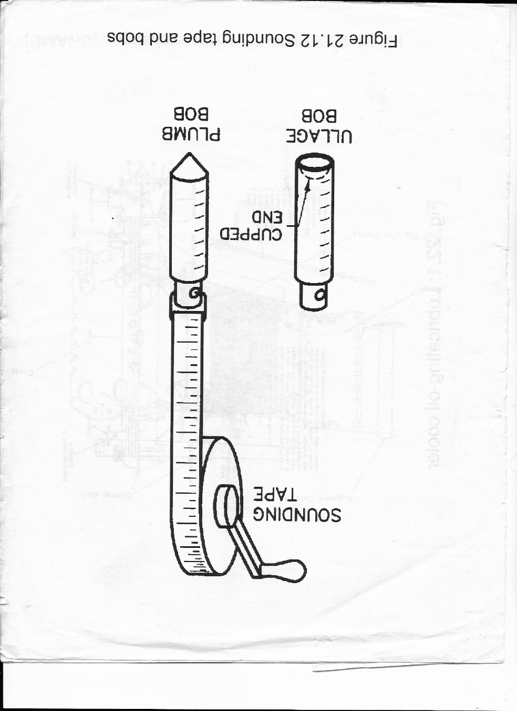

Figure 6.5.9: Sounding Tape with Plumb (Innage) or Ullage bobs.

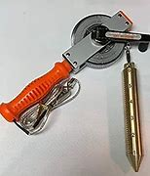

Figure 6.5.10: Sounding Tape with Innage Bob and Grounding Strap

**Innage Sounding** **Value** is the measure from the top of the liquid to the bottom of the sounding tube (using innage/plumb bob). See Figure 6.5.11 below.

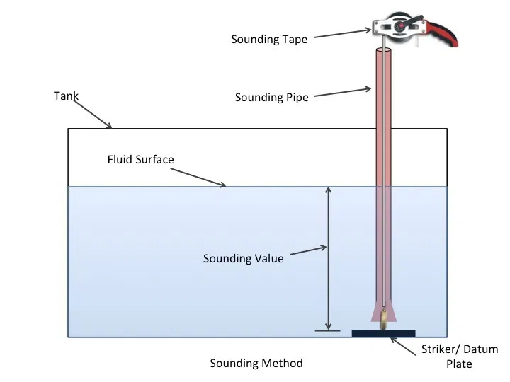

Figure 6.5.11: Innage Sounding

**Ullage Sounding Value** is the measure from the top of the liquid (using ullage bob) to the top of the sounding tube. See Figure 6.5.12.

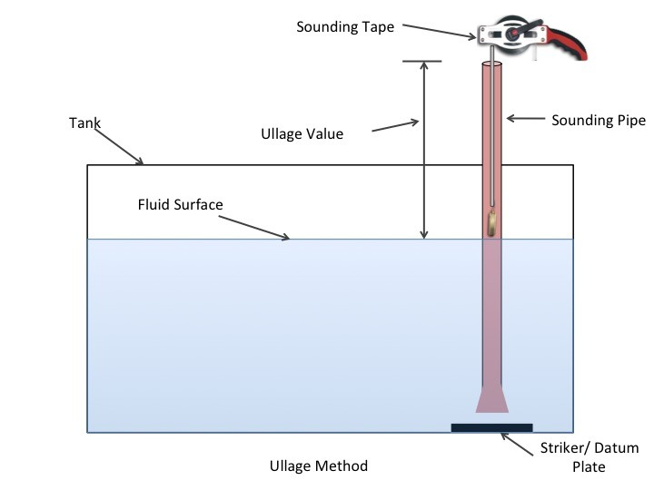

Figure 6.5.12: Ullage Sounding

**Electronic Sounding Gauges:** In electronic sounding, a sensor is used which senses the pressure inside the sounding pipe or by sensing the tank pressure and sends a signal to the receiver. Here the signal is translated to the tank’s content value with the help of a PLC circuit. The value is displayed using an electrically operated servo gauge or electrical capacitance gauge.

**Electrically Powered Servo-Operated Gauges:** This tank gauging system is based on the principle of displacement measurement. A small displacer is accurately positioned in the liquid medium using a servo motor. The displacer is suspended on a measuring wire that is wound onto a finely grooved drum housing within the instrument.

**Pneumercator (Bubbler) Gauges:** This gauging system works on the principle of hydrostatic pressure measurement to determine liquid level. The pressure created by the actual depth of liquid is fed to the gauge which moves the reading until an equilibrium is reached.

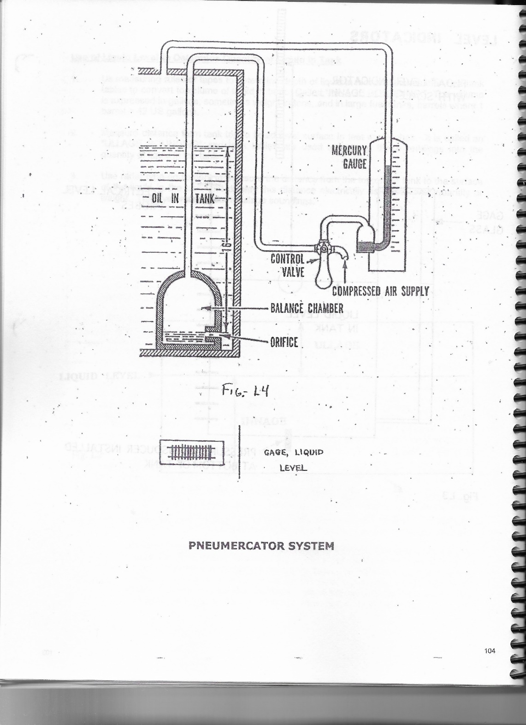

Figure 6.5.13: Pneumercator (Bubbler) Gage

**Ultrasonic Gauges:** This works on principle similar to that of an echo sounder wherein an ultrasonic wave is thrown from the gauge.  The sensor detects the echo from the surface and routes it back to the microprocessor for a digital representation of the distance between the sensor and the surface level.

**Mechanical Sounding Gauges:** Mechanical provisions are made inside the tank so that the quantity of a tank can directly be read through a level marker, an indicator, or a float level sensor. In the tank a float can be attached to a pointer through a pulley. As the level varies, the pointer reading will change accordingly. A level gauge glass is also attached to the tank to read the quantity of the fluid inside the tank. The gauge may also be a pneumatic/hydraulic operated gauge or differential pressure gauge.

**Bunkering or Taking on Fuel Oil Aboard Ship**

**Bunker Calculation:** Bunker quantity calculations are critical calculations which every marine engineer should be familiar with throughout his/her career. Bunker fuel, being a highly valued product, has to be very carefully and accurately calculated for determining the quantity.

The volume of a definite quantity of bunker increases with an increase in temperature whereas its weight remains the same. For this reason, the bunker is always ordered and measured in weight and not by volume.

The density of fuel oil (in kg/) at a standard reference temperature of 15⁰C is always provided by the supplier in *Bunker Delivery Note*. With this, the density of fuel oil at tank temperature can be determined using an ASTM table or using software most commonly installed on all ship’s computer.

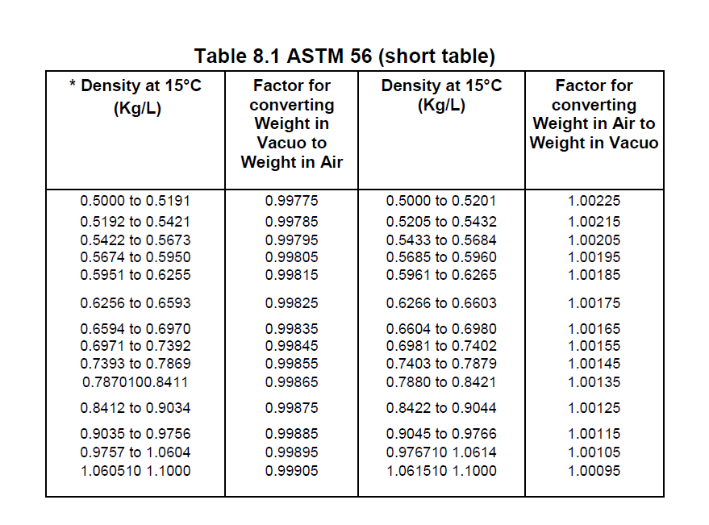

Figure 6.5.14: ASTM Table

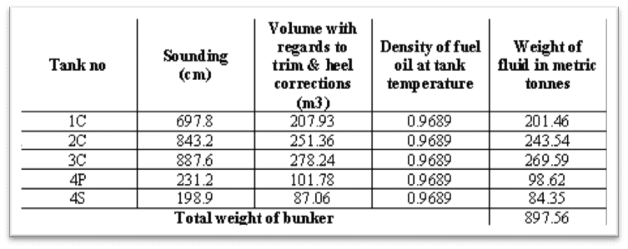

Figure 6.5.15: Bunker Weight

**FORMULAS for Calculating Volume of different shapes**

The method for measuring volume depends on the shape of the object. For simple shapes like cubes, rectangular prisms, cylinders, and spheres, there are specific formulas you can use. For example:

**Cube:** The volume of a cube or rectangular prism is calculated by multiplying the length, width, and height.

**The volume, V, of a** [**cube**](https://www.math.net/cube) **with edge, s, is:**

**V = s3**

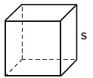

**Cylinder**

The volume, V, of a [cylinder](https://www.math.net/cylinder) is:

The volume of a cylinder is calculated by multiplying the area of its base (usually a circle) by its height.

V = π r2 h

where r is the radius of the base and h is the height of the cylinder.

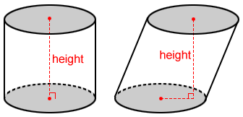

**Sphere**

**The volume, V, of a** [**sphere**](https://www.math.net/sphere) **with radius, r, is:**

The volume of a sphere is calculated using the formula V = (4/3) πr3.



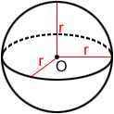

For irregularly shaped objects, you can use techniques like water displacement, where you submerge the object in water and measure the volume of water displaced.

**Examples of Volume (capacity)**

The basic unit of volume in the metric system is a cube, 10 centimeters on each side. Contained in this cube are 1,000 cubic centimeters or one liter. A liter contains slightly more liquid than a quart. Very large volumes may be measured in cubic meters (1 cubic meter = about 264 gallons).

Liquid Measure  
1 liter = 1.057 (1) quart  
1 quart = .9464 (1) liter  
1 liter = .2642 (.25) gallons  
1 gallon = 3.785 (4) liters  
1 dekaliter (dal) = 2.642 (2.5) gallons

Dry Measure  
1 cubic meter = 1.308 (1.3) cubic yards  
1 cubic yard = .7646 (.76) cubic meters  
1 bushel = 1.244 (1.25) cubic feet  
1 bushel = .0352 (.035) cubic meters  
1 cubic meter = 28.38 (30) bushels

Understanding volume is essential in various scientific fields, including physics, chemistry, engineering, and biology. It is used to describe the capacity of containers, the displacement of fluids, the size of objects, and many other aspects of spatial measurements.

In summary, you can calculate volume using specific formulas depending on the shape of the object.

Mastering the concept of volume will be indispensable in your engineering endeavors. Whether you're designing structures, analyzing fluid flows, or working on nautical projects, understanding volume measurements will enable you to tackle complex challenges and create innovative solutions that shape the world around us.